It sounds like you're interested in projects related to Amazon and Python. There are many possibilities for projects in this area, depending on your interests and expertise. Here are a few ideas to consider. Creating a Python project related to Diwali sales can be an exciting endeavor. Here's a simplified outline to get the started.

Data Collection:

Gather or generate sample sales data for products sold during Diwali. This could include items, prices, quantities sold, and customer information.

Create a dataset containing details about the products on sale. Include attributes like product name, category, price, and discounts.

**Data Preprocessing**

Handle missing values, remove duplicates, and correct inconsistencies in the data.

Extract useful features from the raw data, such as total sales amount, discounts applied, and profit margins.

**Data Analysis:**

Analyze sales trends over time leading up to Diwali. Identify popular products and categories.

Group customers based on their purchasing behavior, demographics, or geographic location.

Determine the effectiveness of different discount strategies on sales.

**Visualization:**

Use libraries like Matplotlib or Seaborn to visualize sales trends over time.

Create visualizations to illustrate customer segments and their characteristics.

Discount Impact Visualization: Show the impact of discounts on sales using charts or graphs.

**Documentation and Presentation:**

Documentation: Document your project, including its purpose, methodologies, and findings.

**Presentation:**

Prepare a presentation summarizing your project and present it to your audience.

**Example Code Snippets:**

Here are some code snippets to get you started:

**Import Libraries and Load Data:**

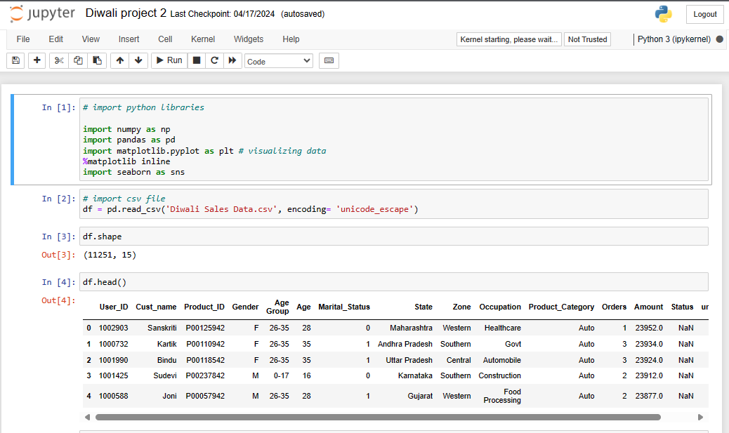

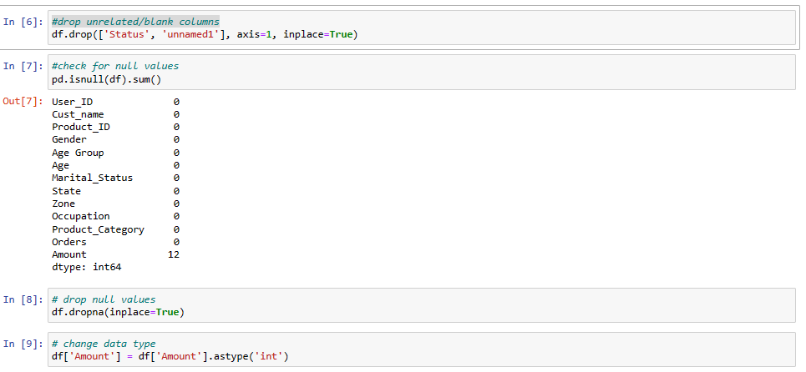

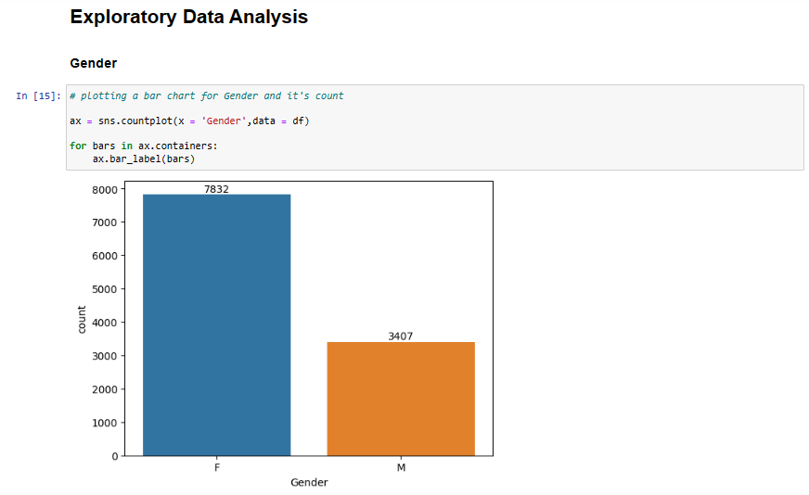

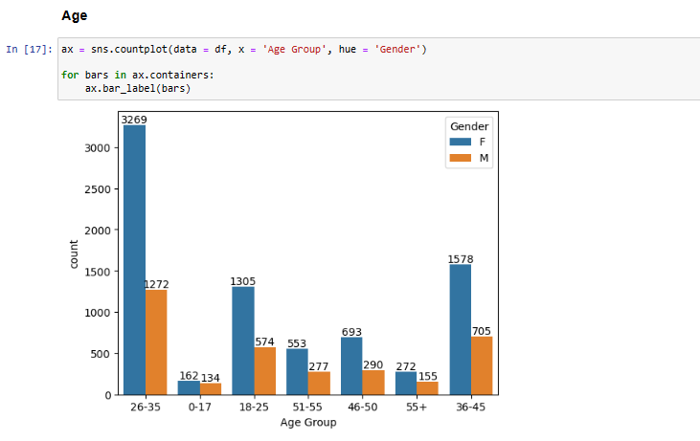

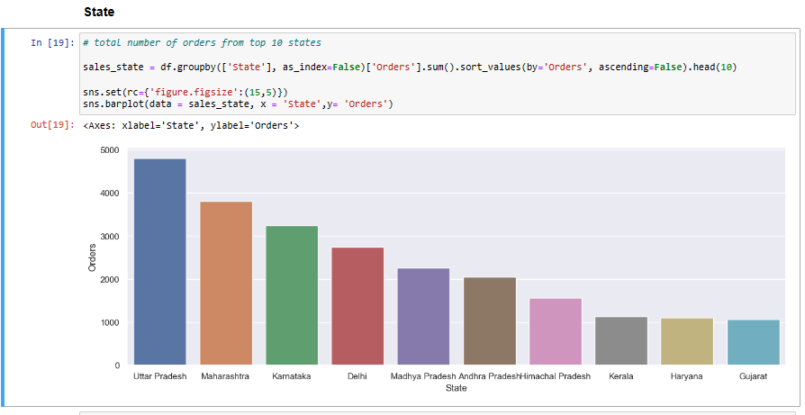

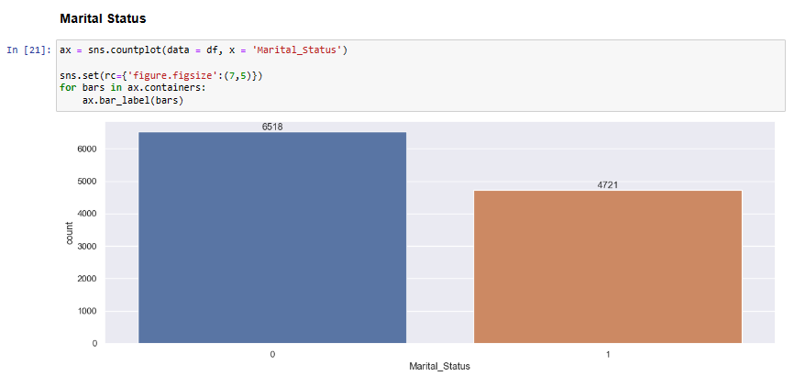

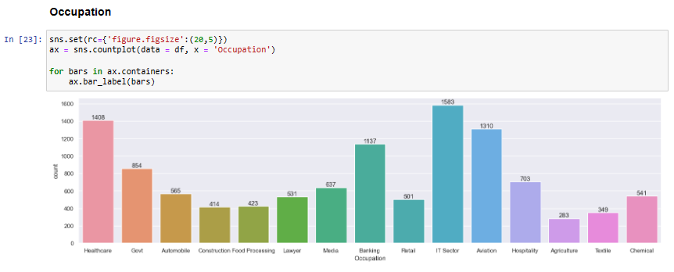

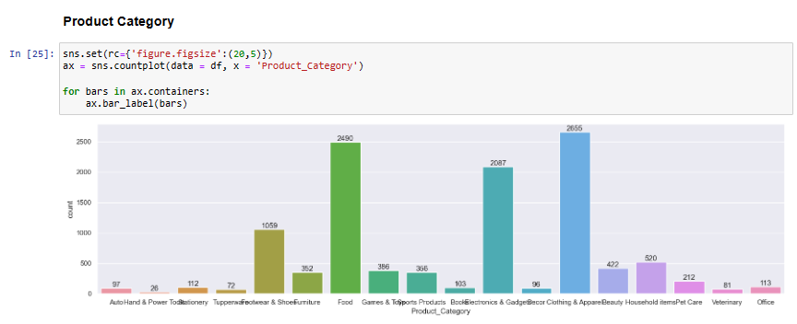

## Conclusion:

Married women age group 26-35 yrs from UP, Maharastra and Karnataka working in IT, Healthcare and Aviation are more likely to buy products from Food, Clothing and Electronics category